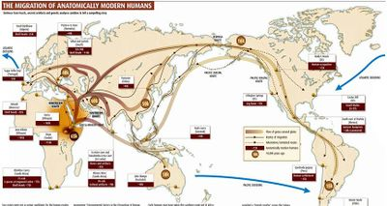
Era 6: Accelerating Global Change and Realignments, c. 1900 to the Present

Key Concept 6.1: Science and the Environment
Rapid advances in science altered the understanding of the universe and the natural world and led to the development of new technologies. These changes enabled unprecedented population growth, which altered how humans interacted with the environment and disrupted delicate ecological balances at local, regional, and global levels.

- Researchers made rapid advances in science that spread throughout the world, assisted by the development of new technology. [Textbook: 890-891; 907-909; 932-935]

- New modes of communication and transportation reduced the problem of geographic distance.

- The Green Revolution produced food for the earth’s growing population as it spread chemically and genetically enhanced forms of agriculture.

- Medical innovations increased the ability of humans to survive and live longer lives.

Illustrative examples of medical innovations:
• Polio vaccine • Antibiotics • Artificial heart

- Energy technologies including the use of petroleum and nuclear power raised productivity and increased the production of material goods.

- During a period of unprecedented global population expansion, humans fundamentally changed their relationship with the environment. [Textbook: 901-907; 932-935]

- As human activity contributed to deforestation, desertification, and increased consumption of the world’s supply of fresh water and clean air, humans competed over these and other resources more intensely than ever before.

- The release of greenhouse gases and other pollutants into the atmosphere contributed to debates about the nature and causes of climate change.

- Disease, scientific innovations, and conflict led to demographic shifts. [Textbook: 774-779; 831-835; 932-938]

- Diseases associated with poverty persisted, while other diseases emerged as new epidemics and threats to human survival. In addition, changing lifestyles and increased longevity led to a higher incidence of certain diseases.
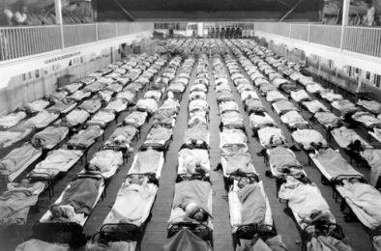
Illustrative examples of diseases associated with poverty:
• Malaria • Tuberculosis • Cholera

Illustrative examples of emergent epidemic diseases:

- The 1918 influenza pandemic
- Ebola
- HIV/AIDS

Illustrative examples of diseases associated with changing lifestyles:
• Diabetes • Heart disease • Alzheimer’s disease

- More effective forms of birth control gave women greater control over fertility and transformed sexual practices.

- Improved military technology and new tactics led to increased levels of wartime casualties.

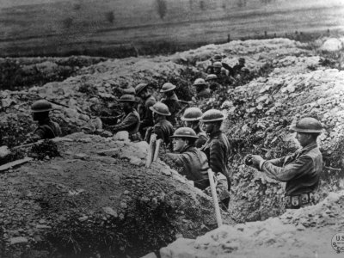
Illustrative examples of improved military technology:
• Tanks • Airplanes • the atomic bomb

Illustrative examples of new military tactics:
• Trench warfare • Firebombing

Illustrative examples of wartime casualties:
• Nanjing • Dresden • Hiroshima

Key Concept 6.2: Global Conflicts and Their Consequences
At the beginning of the twentieth century, a European-dominated global political order existed, which also included the United States, Russia, and Japan. Over the course of the century, peoples and states around the world challenged this order in ways that sought to redistribute power within the existing order and to restructure empires, while those peoples and states in power attempted to maintain the status quo. Other peoples and states sought to overturn the political order itself. These challenges to, and the attempts to maintain, the political order manifested themselves in an unprecedented level of conflict with high human casualties. In the context of these conflicts, many regimes in both older and newer states struggled with maintaining political stability and were challenged by internal and external factors, including ethnic and religious conflicts, secessionist movements, territorial partitions, economic dependency, and the legacies of colonialism.

- Europe dominated the global political order at the beginning of the twentieth century, but both land-based and transoceanic empires gave way to new states by the century’s end. [Textbook: 764-779; 839-842; 861-875]

- The older land-based Ottoman, Russian, & Qing empires collapsed due to a combination of internal & external factors.

Illustrative examples of internal and external factors:
- Political and social discontent
- Technological and economic stagnation
- Military defeat

- Some colonies negotiated their independence.

Illustrative examples of negotiated independence:

- India from the British Empire
- The Gold Coast from the British Empire
- French West Africa

- Some colonies achieved independence through armed struggle.

Illustrative examples of independence through armed struggles:
• Algeria and Vietnam from the French empire • Angola from the Portuguese empire

- Emerging ideologies of anti-imperialism contributed to the dissolution of empires and the restructuring of states. [Textbook: 800-808; 811-817; 861-875; 915-916]

- Nationalist leaders in Asia and Africa challenged imperial rule.
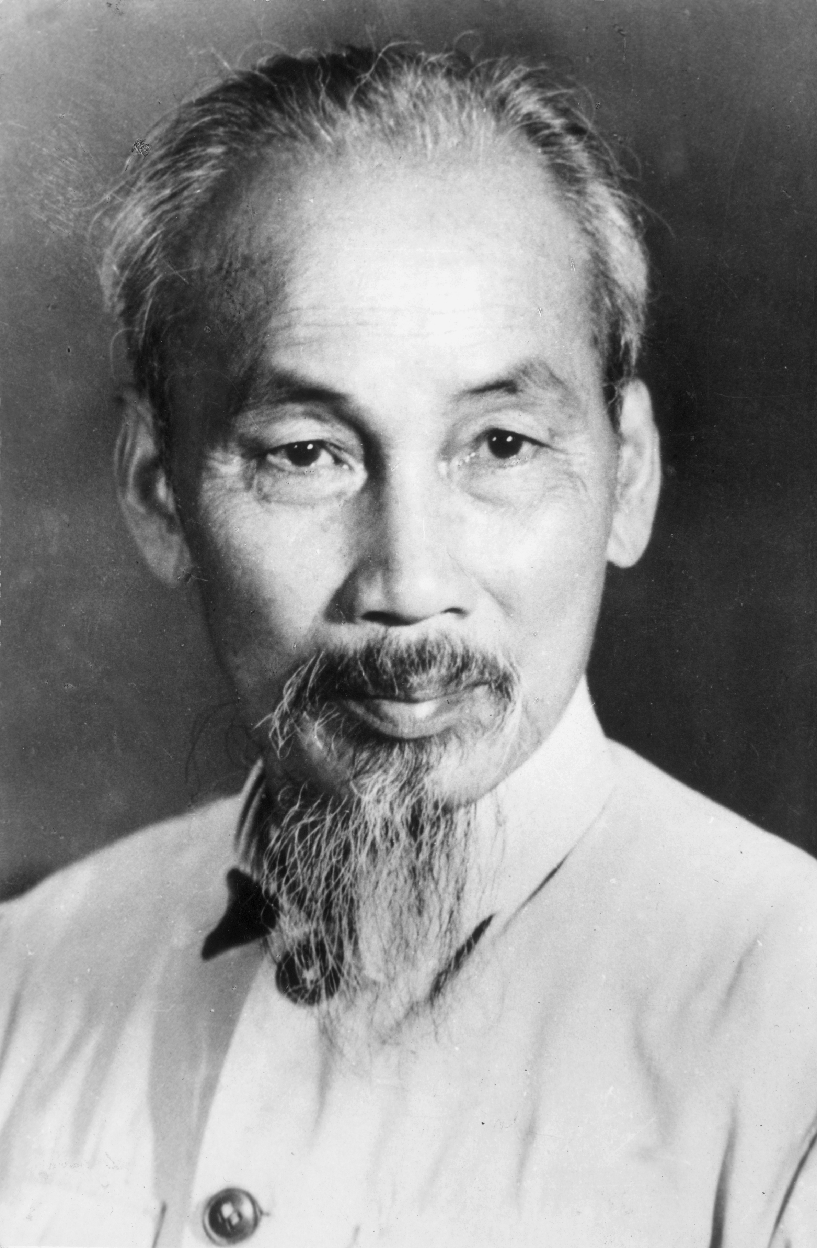
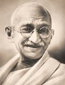
Illustrative examples of nationalist leaders and parties:
• Indian National Congress • Kwame Nkrumah in British Gold Coast (Ghana) • Ho Chi Minh in French Indochina (Vietnam)

- Regional, religious, and ethnic movements challenged both colonial rule and inherited imperial boundaries.
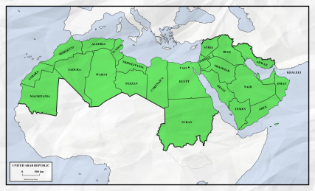
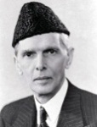
Illustrative examples of regional, religious, and ethnic movements:
• Muhammad Ali Jinnah in British India
• The Québécois separatist movement in Canada
• The Biafra secessionist movement in Nigeria

- Transnational movements sought to unite people across national boundaries.

Illustrative examples of transnational movements:
• Communism • Pan-Arabism • Pan-Africanism

- Movements to redistribute land and resources developed within states in Africa, Asia, and Latin America, sometimes advocating communism and socialism.

- Political changes were accompanied by major demographic and social consequences. [Textbook: 777-779; 842-846; 871-873; 899]
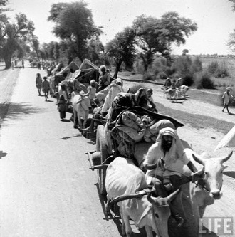
- The redrawing of old colonial boundaries led to population displacement and resettlements.

Illustrative examples of population resettlements and creation of refugee populations:
• The India/Pakistan partition
• The Zionist Jewish settlement of Palestine and displacement of Palestinians
• The division of the Middle East into mandatory states

- The migration of former colonial subjects to imperial metropoles (the former colonizing country, usually in major cities) maintained cultural and economic ties between the colony and the metropole even after the dissolution of empires.

Illustrative examples of migrations:
• South Asians to Britain • Algerians to France • Filipinos to the United States

- The proliferation of conflicts led to the Holocaust in World War II and other forms of genocide or ethnic violence.
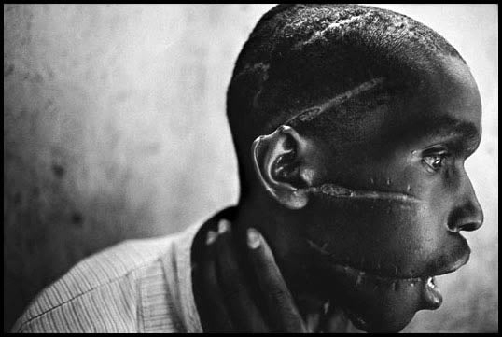
Illustrative examples of genocide or ethnic violence:
- Armenians in Turkey during and after World War I
- Cambodia during the late 1970’s
- Tutsi in Rwanda in the 1990’s

- Military conflicts occurred on an unprecedented global scale. [Textbook: 764-773; 797-800; 817-821; 835-852; 857-875]

- World War I and World War II were the first “total wars.” Governments used ideologies, including fascism, nationalism and communism, to mobilize all of their state’s resources, including peoples, both in the home countries and the colonies or former colonies, for the purpose of waging war. Governments also used a variety of strategies, including political speeches, art, media, and intensified forms of nationalism, to mobilize these populations.

- The sources of global conflict in the first half of the century varied and included imperialist expansion by European powers and Japan, competition for resources, and the economic crisis engendered by the Great Depression.

- The global balance of economic and political power shifted after the end of World War II and rapidly evolved into the Cold War. The United States and the Soviet Union emerged as superpowers, which led to ideological struggles between capitalism and communism throughout the globe.

- The Cold War produced new military alliances, including NATO and the Warsaw Pact, and promoted proxy wars in Latin America, Africa, and Asia.

- Although conflict dominated much of the 20th century, many individuals and groups — including states — opposed this trend. Some individuals and groups, however, intensified the conflicts. [Textbook: 811-813; 873-875; 877-883; 886-888; 894-895; 899-901; 904-906; 909-910; 927-932]

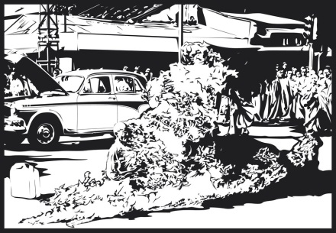
- Groups and individuals challenged the many wars of the century, and some promoted the practice of nonviolence as a way to bring about political change.

Illustrative examples of groups and individuals who challenged war:
• Picasso in his Guernica
• The antinuclear movement during the Cold War
• Thich Quang Duc by self-immolation

Illustrative examples of individuals promoting nonviolence:

- Mohandas Gandhi
- Martin Luther King, Jr.
- Nelson Mandela in South Africa

- Groups and individuals, including the Non-Aligned Movement, opposed and promoted alternatives to the existing economic, political, and social orders.

Illustrative examples of groups or individuals opposing or promoting alternatives:
• The Anti-Apartheid Movement in South Africa
• Participants in the global uprisings of 1968
• The Tiananmen Square protesters that promoted democracy in China

- Militaries & militarized states often responded to the proliferation of conflicts in ways that further intensified conflict.

Illustrative examples of responses that intensified conflict:
• The promotion of military dictatorship in Chile, Spain, and Uganda
• The buildup of the “military-industrial complex” and weapons trading

- More movements used violence against civilians to achieve political aims.

Illustrative examples of movements that used violence:
• IRA • ETA • Al-Qaeda

Key Concept 6.3 New Conceptualizations of Global Economy, Society, and Culture
The 20th century witnessed a great deal of warfare and the collapse of the global economy in the 1930s. In response to these challenges, the role of state in the domestic economy fluctuated, and new institutions of global governance emerged and continued to develop throughout the century. Scientific breakthroughs, new technologies, increasing levels of integration, changing relationships between humans and the environment, and the frequency of political conflict all contributed to global developments in which people crafted new understandings of society, culture, and historical interpretations. Institutions of global governance both shaped and adapted to these social conditions.

- States responded in a variety of ways to the economic challenges of the 20th century. [Textbook: 787-790; 797-799; 801-803; 857-859; 881-883; 889-890; 893-896; 907-910; 920-925]

- In the Communist states of the Soviet Union and China, governments controlled their national economies.

Illustrative examples of communist governments controlling their national economies:
• The Five-Year Plans • The Great Leap Forward

- At the beginning of the 20th century in the United States and parts of Europe, governments played a minimal role in their national economies. With the onset of the Great Depression, governments began to take a more active role in economic life.

Illustrative examples of government intervention in the economy:
• The New Deal • The fascist corporatist economy

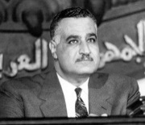
- In newly independent states after World War II, governments often took on a strong role in guiding economic life to promote development.

Illustrative examples governments guiding economic life:
• Nasser’s promotion of economic development in Egypt
• The encouragement of export-oriented economies in East Asia

- In a trend accelerated by the end of the Cold War, many governments encouraged free-market economic policies and promoted economic liberalization in the late 20th century.

Illustrative examples of governments encouraging free-market policies:

• The United States beginning with Ronald Reagan
• Britain under Margaret Thatcher
• China under Deng Xiaoping
• Chile under Pinochet

- States, communities, and individuals became increasingly interdependent, a process facilitated by the growth of institutions of global governance. [Textbook: 774-775; 846-851; 884-885; 911; 920-925; 938-940]

- New international organizations formed to maintain world peace and to facilitate international cooperation.

Illustrative examples of new international organizations:
• The League of Nations • The United Nations • The International Criminal Court

- Changing economic institutions and regional trade agreements reflected the spread of principles and practices associated with free-market economics throughout the world.

Illustrative examples of changing economic institutions:
- The International Monetary Fund (IMF)
- World Bank
- World Trade Organization (WTO)
- Multi-national corporations (MNC)

Illustrative examples of regional trade agreements:

- The European Economic Community (EEC)
- North American Free Trade Agreement (NAFTA)
- Association of Southeast Asian Nations (ASEAN)
- Mercosur

- Movements throughout the world protested the inequality of environmental & economic consequences of global integration.

Illustrative examples of protest movements:
• Greenpeace • Green Belt in Kenya • Earth Day

- People conceptualized society and culture in new ways; rights-based discourses challenged old assumptions about race, class, gender, and religion. In much of the world, access to education, as well as participation in new political and professional roles, became more inclusive in terms of race, class, and gender. [Textbook: 810-811; 875-883; 899-901; 838-840]

Illustrative examples of challenges to assumptions about race, class, gender, and religion:

- The U.N. Universal Declaration of Human Rights especially as it sought to protect the rights of children, women, and refugees
- Global feminism movements
- Negritude movement
- Liberation theology in Latin America
- Islamic renewal movements in Egypt and Saudi Arabia

Illustrative examples of increased access to education and political and professional roles:
- The right to vote and hold public office granted to women in the U.S. (1920), Brazil (1932), Turkey (1934), Japan (1945), India (1947), and Morocco (1963).
- The rising rate of female literacy, and the increasing numbers of women in higher education, in most parts of the world.
- The U.S. Civil Rights Act of 1965
- The end of apartheid
- Caste and reservation in the Indian Constitution of 1949

- Popular and consumer culture became more global. [Textbook: 943]

Illustrative examples of global culture:

- World Cup Soccer
- The Olympics
- Reggae
- Bollywood

